RAWLINS INTERAGENCY DISPATCH CENTER

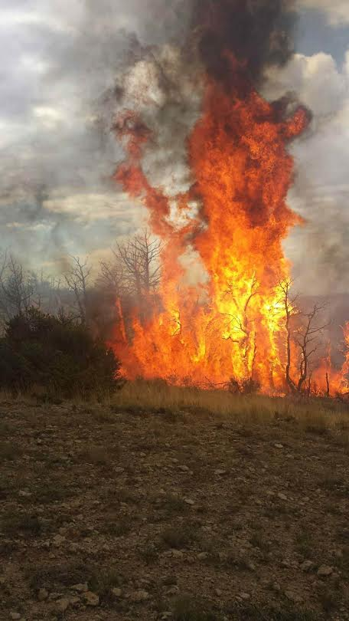
1 Montgomery RX

2015 ANNUAL REPORT

Prepared by Gary Batchelder, Acting Center Manager
Introduction to the Center
Rawlins Interagency Dispatch Center is hosted by Bureau of Land Management’s High Desert District. The center is located in Rawlins, WY. Rawlins is a town of 9,700 people located off Interstate 80 in the middle part of the lower half of Wyoming. We provide services for seven counties, four BLM Field Offices, BLM Wyoming State Office, Wyoming State Forestry, the National Park Service, and the US Fish & Wildlife Service.

Our staff includes one Center Manager, one Assistant Center Manager, one permanent full time Initial Attack Dispatcher, and one career-seasonal Logistics Dispatcher to be hired spring of 2015. During the summer months we hire one to three seasonal dispatchers. This year we had two seasonal dispatchers.

The dispatch zone covers approximately 21 million acres in the state of Wyoming. 48% of this land is owned by the Federal Government (approximately 10 million acres). A large percent of the High Desert District is checkerboard due to the Union Pacific Railroad that runs through Southern Wyoming. This type of land ownership is cause for a multiple agency response to incidents throughout the District.

Center Funding
Rawlins Dispatch Center is funded predominantly by the Bureau of Land Management through the High Desert District. This includes facility costs for the center as well as labor costs associated with staffing the center. All personnel are BLM funded employees, assigned to the High Desert District’s Fire Management program.

FY15 Projected labor costs
Center Manager | GS 11/1 | $65,000*
Asst. Center Manager | GS 9/1 | $76,000
IA/Aircraft Dispatcher | GS 7/1 | $58,000
Logistics Dispatcher | GS 7/1 | $28,000
Seasonal Dispatcher | GS 5/1 | $15,000
 |  | $242,000.00
*NC detail reduced CM labor cost by approx. $30K

Projected cost of fully staffed dispatch center
Center Manager | GS 11/1 | $94,000
Asst. Center Manager | GS 9/1 | $76,000
IA/Aircraft Dispatcher | GS 7/1 | $58,000
Logistics Dispatcher | GS 7/1 | $28,000
Seasonal Dispatcher | GS 5/1 | $15,000
Seasonal Dispatcher | GS 5/1 | $15,000
 |  | $286,000.00

Supporting funds for 2014 included $3,000 was contributed by Wyoming State Forestry, $2,000 from the Department of Fish and Game and $500 from Carbon County to support. Due to reduced budgets and funding cuts, RWC actively solicits funds from the agencies it continues to support.

Overview of the 2014 Year

In 2014, the Center Manager position was filled with Scott Russell in January. The Assistant Center Manager was filled with Gary Batchelder in April and Ashley Hutton Powell accepted and filled the PFT IA/Aircraft Dispatcher in May. During the fire season 2 IA dispatchers were filled in May with Kevin Quinn and Alyssa Hammond. Their season lasted until 10/3. The logistics dispatcher was not filled, but will be advertised in the spring of 2015. Staffing for the winter of 2013/14 included, Center Manager Scott Russell and firefighter Andy Williams. Andy was brought in to provide dispatch coverage while Scott attended required training and meetings. The staff was new either to their positions or new to fire dispatching, there was a learning curve for everyone but the season was very successful.

Center Activity
The number of fires during the 2014 season was below average with 63 total fires for 197ac, this includes fire on BLM and county’s that fall within the HDD response area.

Notable incidents:
Fire hole – Started 7/7/14, burned a total of 36.7 acres. Fire started on private property from fireworks, and burned onto BLM land, 33acs on pvt and 3.7acs on BLM. Fuels where brush and grass.
Pedro – Started 7/12/14, burned a total of 35 acres. This lightning caused fire had rapid rates of spread in PJ. The IC called for a load of jumpers, 1 type 1 crew T1 helicopter air attack and 2 SEATs. Fire was contained on the 12th and controlled on the 14th.
Strip Mine – Started 8/16/14, burned a total of 38.7 acres. IC for this lightning caused fire ordered a couple of SEATs type 3 helicopter and a type 2 crew. Fuels were PJ with 100% of the fire being on private land.
Rock Ridge Medical – Incident within an incident. During suppression efforts of the Rock Ridge fire, a member of a county engine was burned. A medevac helicopter was ordered out of Rock Springs along with a ground ambulance. There was difficulty with communication between ground resources and the helicopter resulting in a delay in evacuating the patient. Several AAR’s have taken place, and there is an effort to fix this communication breakdown.
Aircraft - RWC was a heavy participant of both the Forest Health flight and the MAFFS training. Forest health flight went for 15 days while MAFFS training went on for 3 days with a number of sorties.

WILDCAD INCIDENTS BY TYPE

INCIDENT TYPE | NUMBER
Aircraft | 14
Medical Aid | 2
Miscellaneous | 8
Prescribed Fire | 12
Resource Order | 53
SAR | 1
Smoke Check | 39
Structure Fire | 4
Vehicle Fire | 2
Wildfire | 65
Total | 200

Resources Sent Out

Given the nature of a moderately slow fire season in southern Wyoming, Rawlins Dispatch was able to fill multiple resource orders for events outside of our zone.

Rawlins Aviation Activity in 2013
BLM Contracted Type 3 Standard Helicopter
N32HX began its 90 day contract on June 15th and ended its season on September 12 of 2014. It was staffed with a module of seven personnel. During its 90 days of contract the helicopter flew 97.0 total hours of which 36.9 of those hours were firefighting operations within the RWC zone. It delivered a total of 26,772 gallons of water, 33,950 pounds of cargo (both internal and externally) and transported 255 passengers.
Rawlins SEAT Base
In support of the 2014 fire season the Rawlins SEAT base was open for approximately 34 days. During that time, one helicopter, 3 Single Engine Air Tankers (SEATs), one jumper plane and 2 Air Attack platform used the facility. In support of four large fires, the SEAT base delivered 5,876 gallons of retardant (at a cost of $16,159) via 8 sorties and 35.14 flight hours (at a cost of $78,247).

WEATHER
In 2014 there were 11 Fire Weather Watch/Warnings days issued for zones within RWC. The first of these was issued April 5th and the last was issued September 14th .
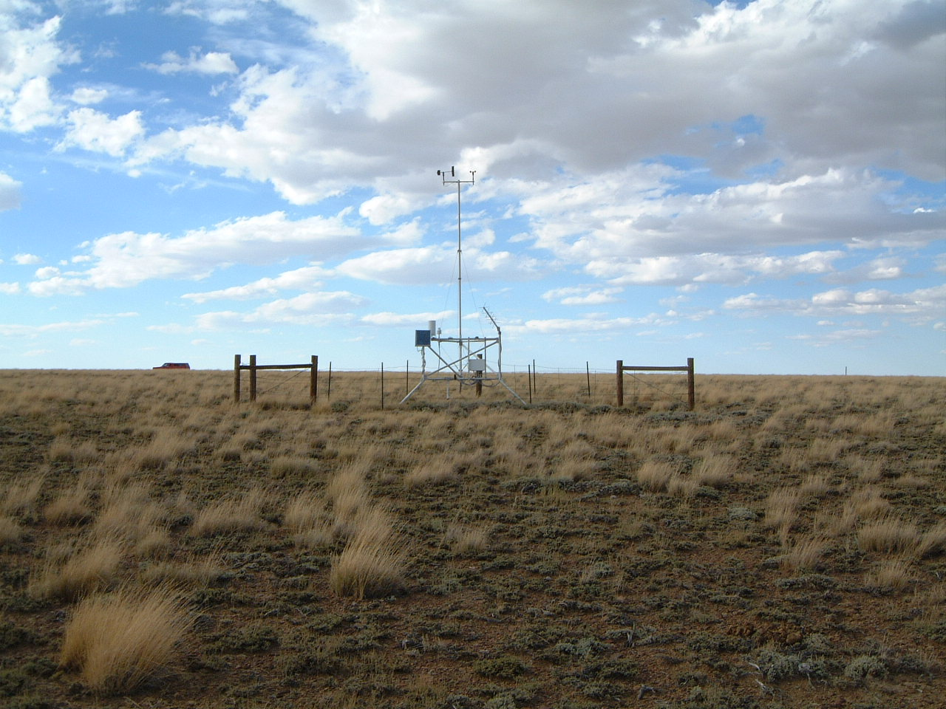
RAWS STATIONS REPORTS
Total Precipitation in Inches | April | May | June | July | August | September | Total
Snow Spring Creek (Sweetwater County) 481904 | .11 | .75 | .16 | 1.09 | 2.88 | 2.3 | 7.29
Dodge Creek (Albany County) 482106 | .46 | 1.63 | .9 | 2.06 | 1.41 | 1.99 | 8.45
Muddy Creek (Uinta County) 481801 | .55 | .78 | 1.04 | 1.17 | 2.06 | 3.15 | 8.75
Anderson Ridge (Sublette County) 481903 | 0 | 0 | .07 | .66 | 2.08 | 1.22 | 4.03
Cow Creek (Carbon County) 482011 | .16 | .43 | .4 | .37 | 3.71 | 1.34 | 6.41

